**Functional Description:**

This application consists of user registration, User login, simple sales order creation, update, delete and Orders data search. Complete application built as **single page** (without refreshing browser URL) application and developed using Angular.

Application navigation is

**User Registration and Login Page=> Orders Creation Page => Orders Search Page => Orders Edit Page.**

First page of the Application: Home Page

Users can register their information and it will be saved in Database using a POST REST service. People with valid credentials only can login.

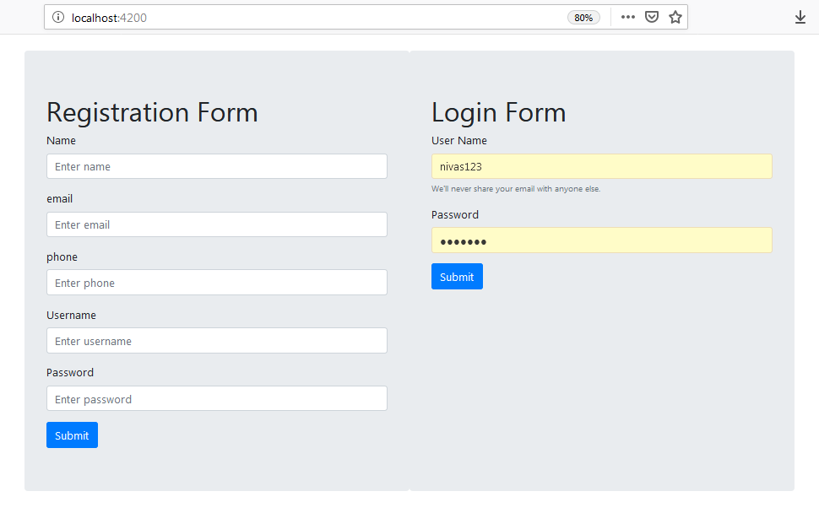

User need to login using credentials.

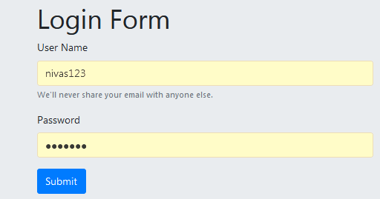

After successful login, user will Route to “Dashboard” page. Now user will have 3 options. “Create Order”, “View Orders” or “Logout”.

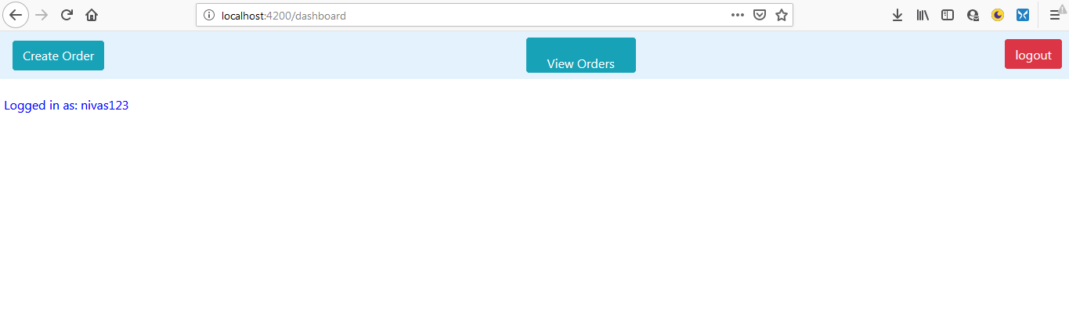

Clicking on “Create order” will load Header component HTML content.

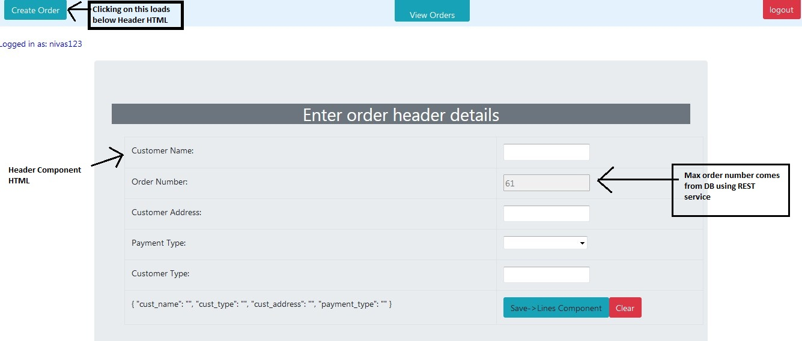

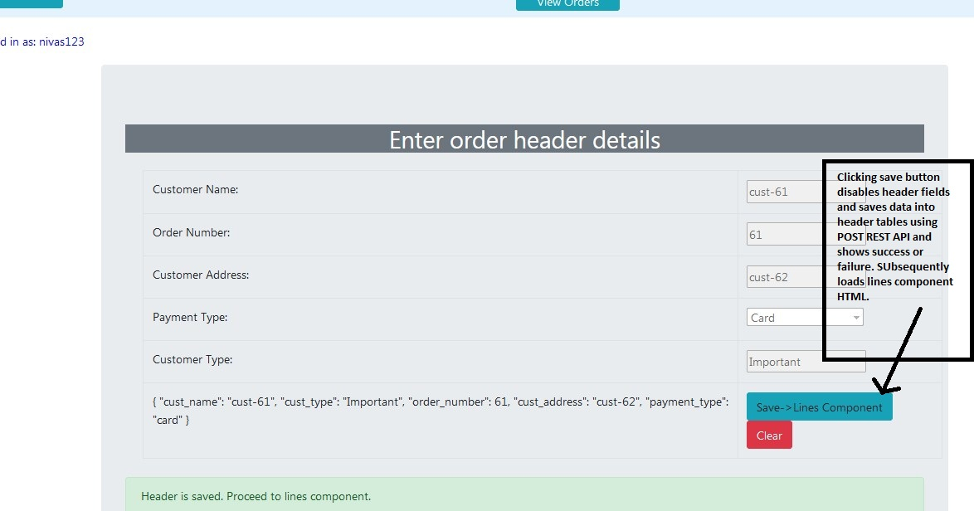

After saving Header Details successfully Lines component(HTML) gets loaded. Also success message can be seen on page.

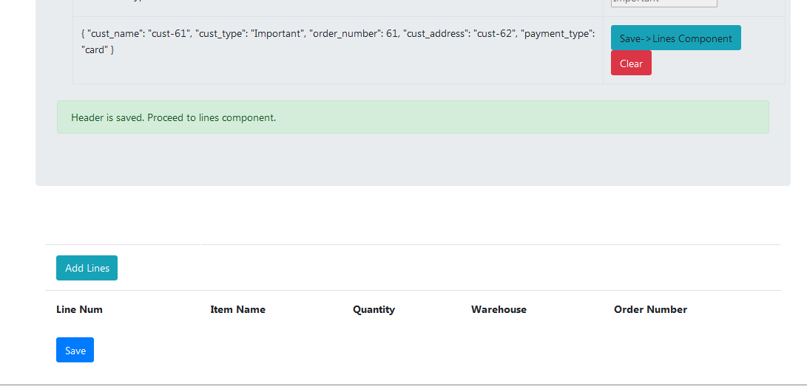

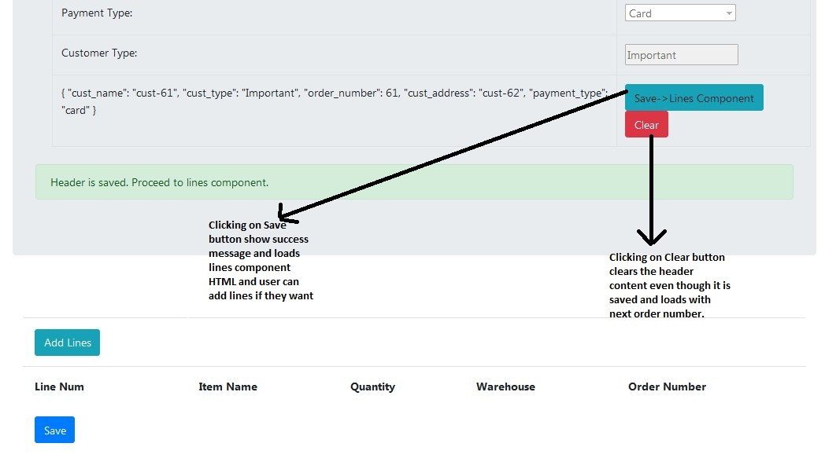

Click on ‘Add Lines’ to add lines as many as we want. Enter line data.

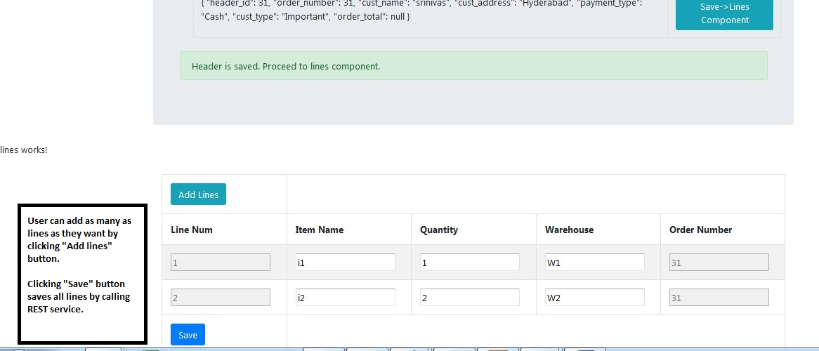

After saving the Order lines, Successful alert will pop up and page will Route Back to “Dashboard” page.

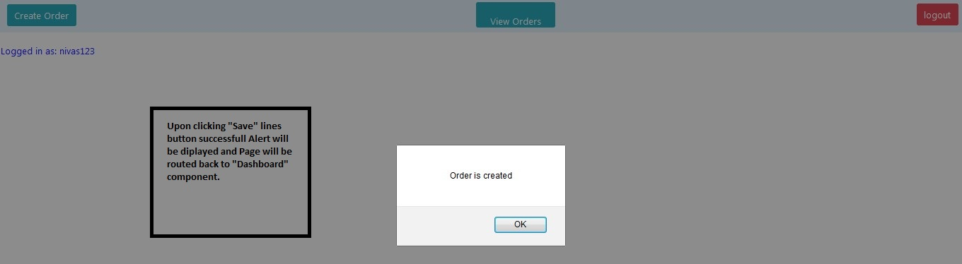

Either user can create a new order or view all orders. Clicking on “View Orders” will load View component and displays all Orders content and users can search data, Edit and Delete them.

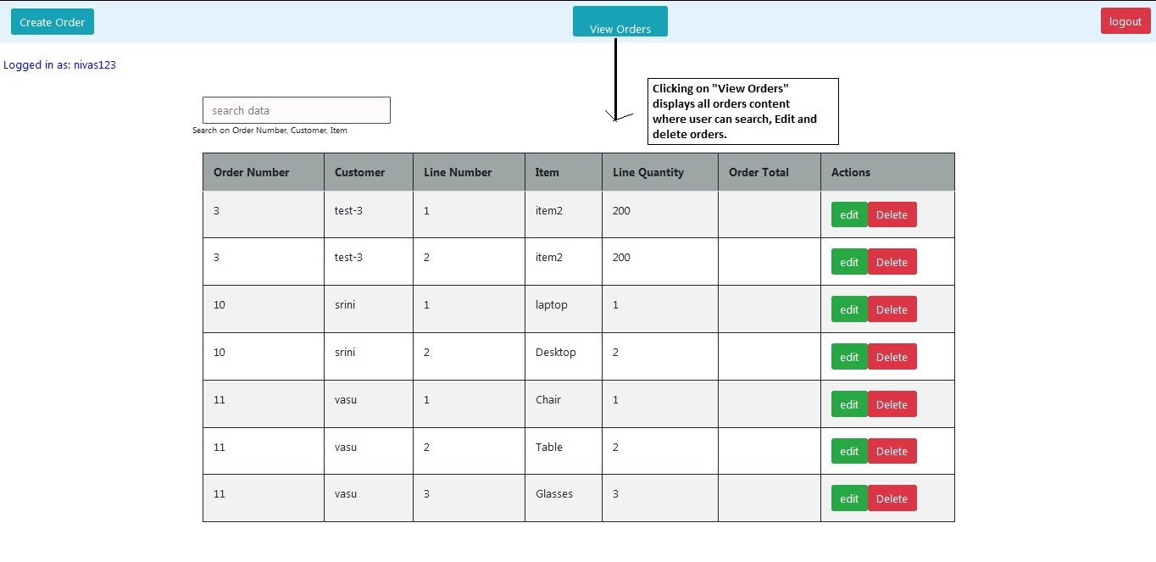

Currently search is enabled on 3 columns Order Number, Customer and Item.

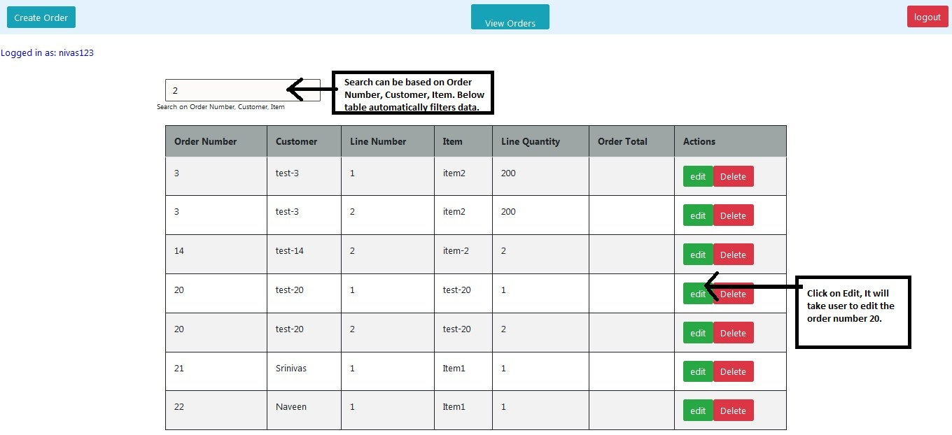

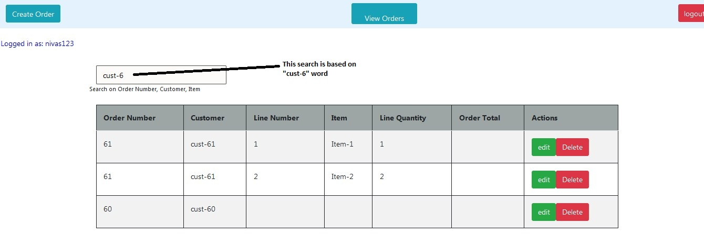

Clicking on “Edit” button will route to “Orders Edit” component and will load order data.

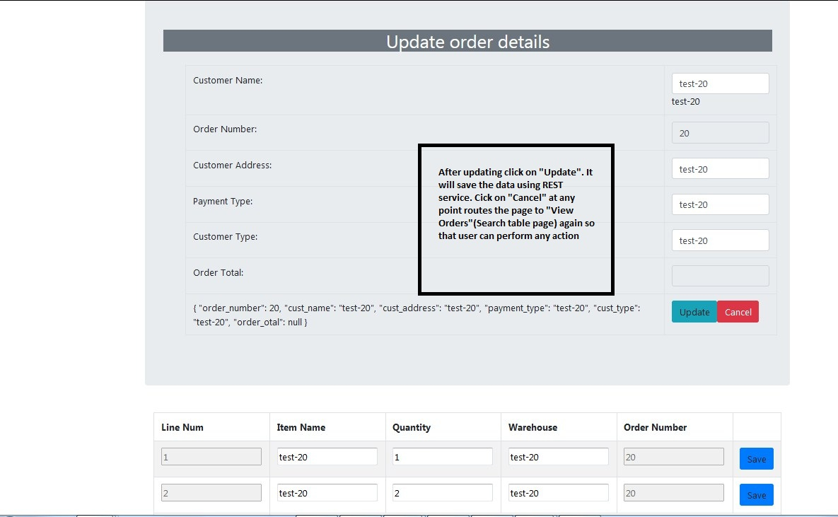

After modifying data can be saved and changed data can be seen in “View Orders” (Search) page.